PIZZA SALES SQL QUERIES

A. KPI’s
1. Total Revenue:
select SUM(total_price) as revenue from pizza_sales;

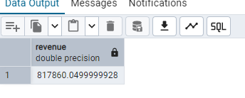

2. Average Order Value:
Select (sum(total_price))/Count(Distinct order_id) as Avg_order_value from pizza_sales;
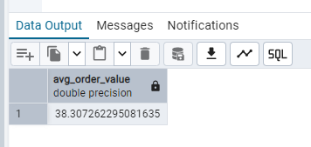

3. Total Pizzas Sold:
select sum(quantity) as total_pizza_sold from pizza_sales;
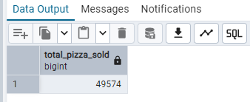
4. Total Orders
select count (distinct order_id) as total_order from pizza_sales;
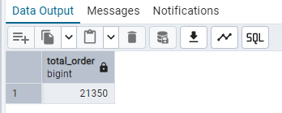
5. Average Pizzas Per Order
select Cast(sum(quantity) as DECIMAL (10,2))/ CAST(COUNT (Distinct order_id) as DECIMAL (10,2)) AS Avg_pizza_order from pizza_sales
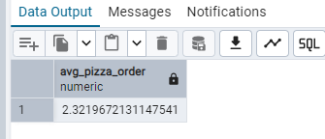

B. Daily Trend for Total Orders

SELECT TO_CHAR(order_date, 'DAY') As week_day, count(distinct order_id) as total_orders from pizza_sales
group by week_day;
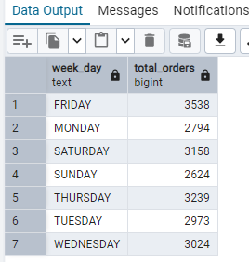

C. Monthly Trend for Orders

SELECT TO_CHAR(order_date, 'Month') As monthly, count(distinct order_id) as total_orders from pizza_sales
group by monthly
order by total_orders desc

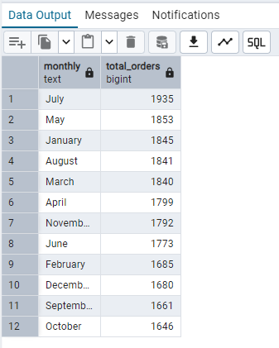

D. % of Sales by Pizza Category
SELECT pizza_category, Sum(total_price) *100 / (Select Sum(total_price) from pizza_sales) As PCT
from pizza_sales
group by pizza_category
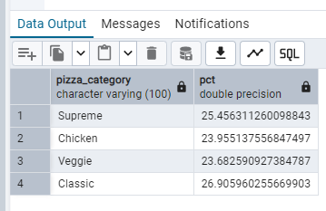
E. % of Sales by Pizza Size
SELECT pizza_size, CAST(SUM(total_price) AS DECIMAL(10,2)) as total_revenue,
CAST(SUM(total_price) * 100 / (SELECT SUM(total_price) from pizza_sales) AS DECIMAL(10,2)) AS PCT
from pizza_sales
group by pizza_size
order by pct desc
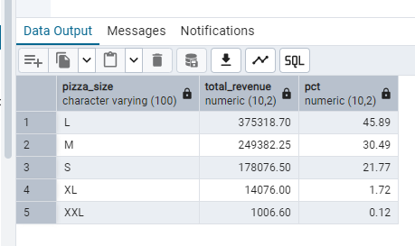

F. Total Pizzas Sold by Pizza Category
SELECT pizza_category, SUM(quantity) as Total_Quantity_Sold
FROM pizza_sales
GROUP BY pizza_category
ORDER BY Total_Quantity_Sold DESC
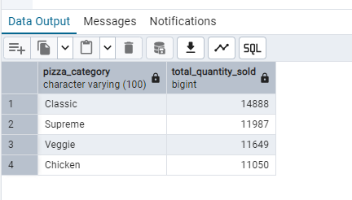

G. Top 5 Pizzas by Revenue

SELECT pizza_name, SUM(total_price) AS total_Revenue
FROM pizza_sales
GROUP BY pizza_name
ORDER BY Total_Revenue DESC
Limit 5
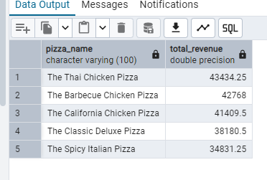
H. Bottom 5 Pizzas by Revenue
SELECT pizza_name, SUM(total_price) AS total_Revenue
FROM pizza_sales
GROUP BY pizza_name
ORDER BY Total_Revenue ASC
Limit 5
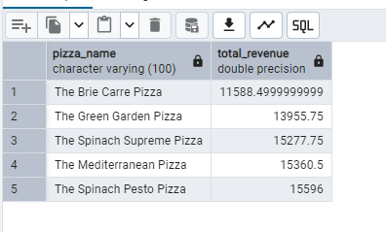
- Top 5 Pizzas by Quantity
SELECT pizza_name, SUM( quantity) AS total_quantity
FROM pizza_sales
GROUP BY pizza_name
ORDER BY total_quantity Desc
Limit 5
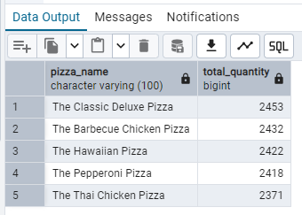
J. Bottom 5 Pizzas by Quantity
SELECT pizza_name, SUM( quantity) AS total_quantity
FROM pizza_sales
GROUP BY pizza_name
ORDER BY total_quantity Asc
Limit 5
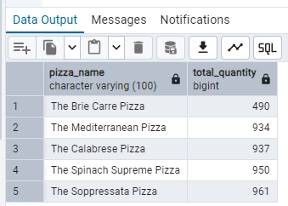
K. Top 5 Pizzas by Total Orders
SELECT pizza_name, Count(Distinct order_id) AS total_quantity
FROM pizza_sales
GROUP BY pizza_name
ORDER BY total_quantity Desc
Limit 5
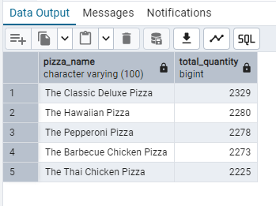
L. Borrom 5 Pizzas by Total Orders
SELECT pizza_name, Count(Distinct order_id) AS total_quantity
FROM pizza_sales
GROUP BY pizza_name
ORDER BY total_quantity Asc
Limit 5

